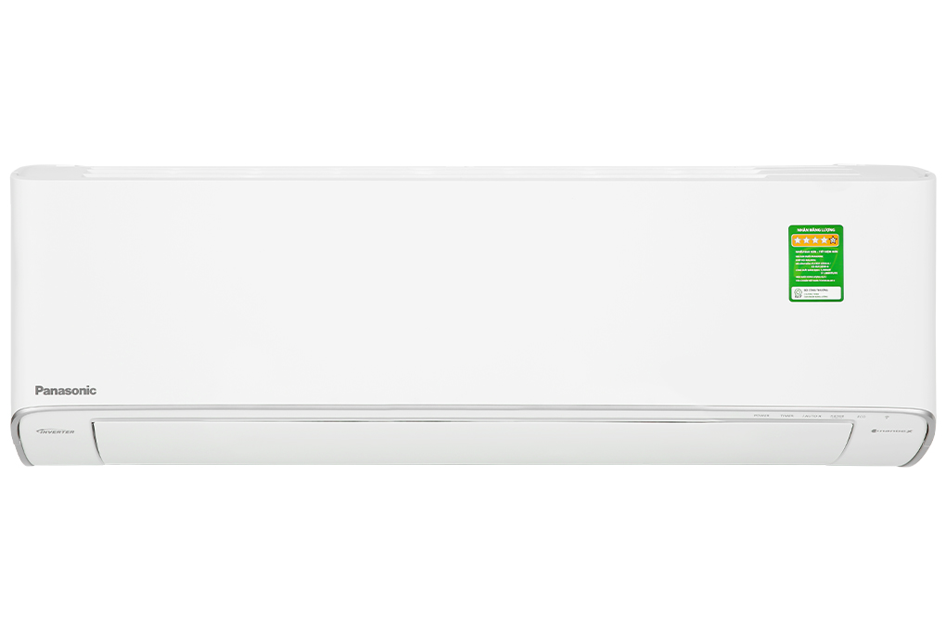

**16,740,000 VND**

(-3%)

**Technical specifications Panasonic Inverter air conditioner 1.5 HP CU/CS-XU12ZKH-8**

* Machine Type:

1 way (cooling only) With Inverter

* Cooling capacity:

1.5 HP - 11,900 BTU

* Effective cooling range:

From 15 - 20m² (from 40 to 60 m³)

* Dust filter, antibacterial, deodorant:

Nanoe™ X generation 3 air filtration technology Nanoe-G filters PM 2.5 fine dust

* Power saving technology:

ECO integrates AI Inverter

* Rapid cooling:

iAuto-X

* Utilities:

Humidity control mode Night sleep mode Sleep for the elderly and children Self-diagnosis function Super quiet operation Quiet timer to turn on and off Automatically restart when power is available Cleaning inside the indoor unit: Inside Cleaning Condition Controlled by phone, with wifi

* Power consumption:

0.95 kW/h 5 stars (Energy efficiency 6.32)

* Cooler:

Length 87 cm - Height 29.5 cm - Thickness 22.9 cm - Weight 10 kg

* Outdoor:

Length 86.3 cm - Height 54.2 cm - Thickness 32.3 cm - Weight 22 kg

Introducing the company 

- Japanese brand.  
- Established in 1918. Panasonic entered the Vietnamese market very early, in the 1950s.  
- Panasonic is famous for its refrigerators, air conditioners, televisions and household appliances such as microwaves, fans, air conditioners. blender...  
- Panasonic products are famous for their high durability, energy saving, and beautiful designs.

[***Panasonic Inverter 1.5 HP CU/CS-XU12ZKH-8 air conditioner***](https://www.dienmayxanh.com/may-lanh/panasonic-inverter-15-hp-cu-cs-xu12zkh-8#2-gia)***has the ability to deodorize, inhibit the growth of viruses and bacteria by up to 99%, and keep the user's hair and skin moist from drying out when using the air conditioner. . In addition, the device can also connect to wifi, allowing users to control the air conditioner with their phone at any time.***

**Design**

**Cooler:**

The indoor unit is designed in white with a high-quality and durable plastic shell, suitable for any installation space. In addition, the front of the indoor unit can be easily removed to facilitate periodic cleaning of the device.

**Outdoor:**

- The outdoor unit of [the air conditioner](https://www.dienmayxanh.com/may-lanh) has a white, horizontal rectangular box shape with a shell material that can withstand climatic conditions when installed outdoors.

- The outdoor and indoor units both use **aluminum heatsinks** , along with durable **copper gas pipes** , capable of quick heat transfer.

**Refrigeration technology**

- This [Panasonic air conditioner](https://www.dienmayxanh.com/may-lanh-panasonic) is designed with **a capacity of 1.5 HP** , suitable for cooling rooms with an area of **​​15 - 20m²** .

- [iAuto-X fast cooling mode](https://www.dienmayxanh.com/kinh-nghiem-hay/cac-che-do-lam-lanh-nhanh-thuong-gap-tren-may-lanh-837183#iauto-x)**with P-TECH technology** : After activation, the air conditioner will operate at highest capacity with strong fan speed, while blowing cold air up to the ceiling, cooling the ceiling. Allows **the room temperature to be quickly lowered by up to 25%** , helping users feel the cool atmosphere immediately while still ensuring comfort.

- **Night Sleep mode** : The air conditioner has the ability to automatically increase the temperature at night, helping the room temperature match the body temperature of the sleeping person, thereby avoiding the feeling of coldness **and providing good sleep. good sleep** for users. This mode is suitable for the elderly, children and women with quite sensitive bodies.

**Air blowing mechanism**

Panasonic 1.5 HP air conditioner can [adjust the air flaps up, down, left and right automatically](https://www.dienmayxanh.com/kinh-nghiem-hay/tac-dung-cua-cac-che-do-gio-tren-may-lanh-588239#dao-gio-tu-dong) , helping cold air spread evenly throughout the area that needs cooling.

**Power saving technologies**

- The product is integrated with Inverter technology and Eco mode, providing outstanding electricity saving efficiency during operation. Specifically:

+  [Inverter technology](https://www.dienmayxanh.com/may-lanh?g=may-lanh-inverter) : Able to adjust the compressor, helping to maintain optimal cold temperature in the room, while also **providing energy saving efficiency and smooth operation** .

+  [AI-integrated ECO mode](https://www.dienmayxanh.com/kinh-nghiem-hay/nhung-cong-nghe-noi-bat-tren-may-lanh-panasonic-1242950#eco-tich-hop-AI) : Able to adjust the operating capacity of the air conditioner to suit the cooling time. The air conditioner quickly reaches the set temperature, while still being able to reduce the compressor's operating capacity by **5 - 50%,** saving significant electricity.

**- Panasonic CU/CS-XU12ZKH-8 air conditioner achieves a 5-star** energy label with efficiency **6.32** and uses about [0.95 kW/h](https://www.dienmayxanh.com/kinh-nghiem-hay/cong-suat-tieu-thu-dien-toi-da-855107) of electricity .

**Air filtration ability - health**

- **Nanoe™ X air filtration technology : Panasonic 's** exclusive air filtration technology, capable of releasing microscopic Nanoe **%** , while optimally eliminating allergens and odors, **providing a clean and safe atmosphere** for users.

Furthermore, this technology can also create water molecules, thereby providing moisture as well as preventing the **user's skin and hair from drying out** while living in an air-conditioned room.

-  [Nanoe-G technology filters fine dust PM 2.5](https://www.dienmayxanh.com/kinh-nghiem-hay/bo-loc-nanoe-g-tren-may-lanh-panasonic-804161) : Releases Nanoe-G molecules with extremely small sizes to remove suspended particles in the air, including fine dust particles PM 2.5, providing the ability **to The ability to filter dust** up to **99%** , thereby helping to better protect the respiratory health of the entire user's family.

*\*Video is for illustration purposes only*

Panasonic and Texcell have shown test results that Nanoe™ This test was performed under closed laboratory conditions and is not designed for evaluation in an uncontrolled living space.

Certificate and testing results from Texcell Global Exposure Research organization on Nanoe™ X technology's ability to inhibit SARS-CoV-2 in the laboratory.

[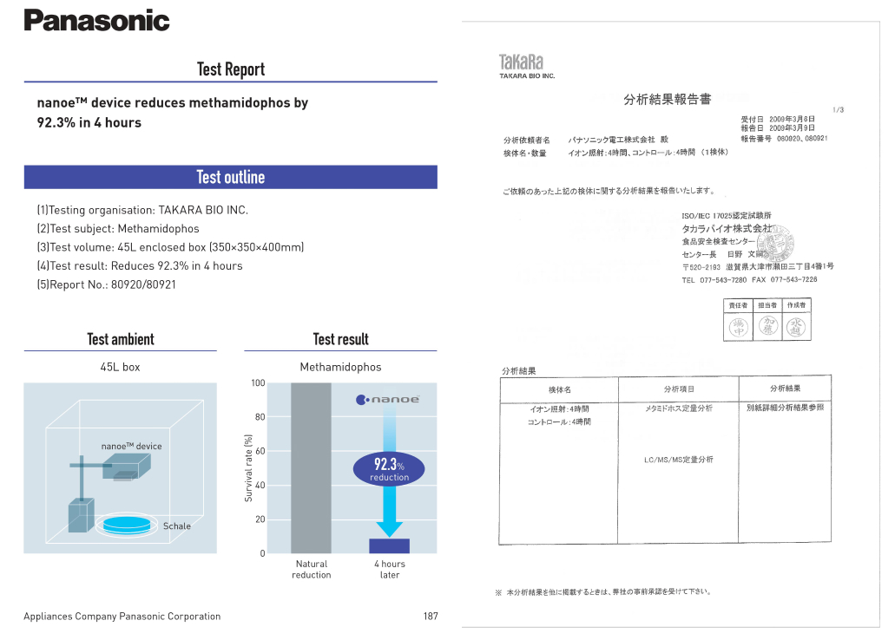](https://cdn.tgdd.vn/Products/Images/2002/303868/may-lanh-panasonic-inverter-15-hp-cu-cs-xu12zkh-8-050623-053149.jpg)

*\* Texcell is the first organization of the Pasteur Institute of Paris established in 1997 specializing in global research on virus testing, virus removal, providing immunity,... With more than 30 years of experience and headquarters Based at the Pasteur Institute Paris, Texcell is recognized for its expertise in virus forensics with a wide range of procedures to detect potential agents.*

See other certificates of Nanoe™ X technology [here](https://www.panasonic.com/vn/nanoe/all/verification/evidence.html#Pesticideresidue_nutritionalvalue) .

**Utilities**

- **Humidity control mode : When**[Dry mode](https://www.dienmayxanh.com/kinh-nghiem-hay/che-do-lam-kho-tren-may-lanh-la-gi-948007) is activated with the use of **the Humidity Sensor** , this [Panasonic Inverter air conditioner](https://www.dienmayxanh.com/may-lanh?g=may-lanh-inverter) can **control optimal humidity** to bring comfort to the user and protect items. Use in rooms to avoid mold.

- **Self-diagnosis function** : Helps users identify and fix air conditioner errors as soon as possible, thereby not affecting the use of the device as well as **saving repair time** when the air conditioner encounters problems. error.

- **Clean inside the indoor unit Inside Cleaning** : Avoid mold and bacteria growth, affecting the cooling efficiency and durability of the indoor unit.

- [Controlled by phone, with wifi](https://www.dienmayxanh.com/may-lanh-co-wifi-chinh-bang-dien-thoai) : Panasonic Inverter 1.5 HP air conditioner has wifi connection capability and users can **remotely control the air conditioner through the application installed on the phone** anytime, anywhere. Thanks to that, users can monitor power consumption, quickly detect problems,... and control air conditioning functions easily.

*\*Images are for illustration purposes only*

*In short, the Panasonic Inverter 1.5 HP CU/CS-XU12ZKH-8 air conditioner helps protect the user's respiratory health optimally, suitable for those with sensitive health such as children, the elderly, women and children. people with breathing problems. At the same time, this product is also suitable for households with many rooms, businesses in the hotel - restaurant industry, etc. thanks to the ability to control the operation of air conditioners remotely through an application on the phone.*